Difference Between IPv4 and IPv6
Last Updated : 01 Jul, 2025

IPv4 and IPv6 are two versions of the system that gives devices a unique address on the internet, known as the Internet Protocol (IP). IP is like a set of rules that helps devices send and receive data online. Since the internet is made up of billions of connected devices, each one needs its own special number an IP address to be found.
IPv4 is the older version and uses a 32-bit address, which allows for about 4 billion unique addresses. It was used to be enough, but with the growth of the internet and smart devices (IoT), we’re running out of IPv4 addresses that’s why IPv6 was created. It uses a 128-bit address, which means it can provide trillions upon trillions of unique addresses, solving the shortage problem and preparing the internet for the future.
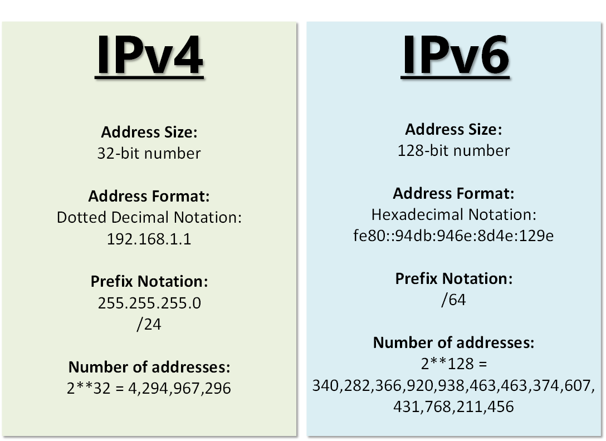
IPV4 Vs IPV6
What is IPv4?
IPv4, or Internet Protocol version 4, is the original addressing system of the Internet, introduced in 1983. It uses a 32-bit address scheme, which theoretically allows for over 4 billion unique addresses (232). IPv4 addresses are typically displayed in decimal format, divided into four octets separated by dots. For example, 192.168.1.1 is a common IPv4 address you might find in a home network.
IPv4 Address Format is a 32-bit Address that comprises binary digits separated by a dot (.).
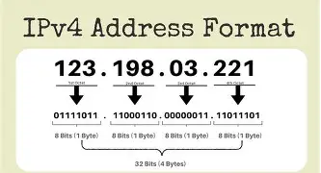
IPV4
Characteristics of IPv4
- 32-bit address length: Allows for approximately 4.3 billion unique addresses.
- Dot-decimal notation: IP addresses are written in a format of four decimal numbers separated by dots, such as 192.168.1.1.
- Packet structure: Includes a header and payload; the header contains information essential for routing and delivery.
- Checksum fields: Uses checksums in the header for error-checking the header integrity.
- Fragmentation: Allows packets to be fragmented at routers along the route if the packet size exceeds the maximum transmission unit (MTU).
- Address Resolution Protocol (ARP): Used for mapping IP network addresses to the hardware addresses used by a data link protocol.
- Manual and DHCP configuration: Supports both manual configuration of IP addresses and dynamic configuration through DHCP (Dynamic Host Configuration Protocol).
- Limited address space: The main limitation which has led to the development of IPv6 to cater to more devices.
- Network Address Translation (NAT): Used to allow multiple devices on a private network to share a single public IP address.
- Security: Lacks inherent security features, requiring additional protocols such as IPSec for secure communications.
Drawbacks of IPv4
- Limited Address Space : IPv4 has a limited number of addresses, which is not enough for the growing number of devices connecting to the internet.
- Complex Configuration : IPv4 often requires manual configuration or DHCP to assign addresses, which can be time-consuming and prone to errors.
- Less Efficient Routing : The IPv4 header is more complex, which can slow down data processing and routing.
- Security Issues : IPv4 does not have built-in security features, making it more vulnerable to attacks unless extra security measures are added.
- Limited Support for Quality of Service (QoS) : IPv4 has limited capabilities for prioritizing certain types of data, which can affect the performance of real-time applications like video streaming and VoIP.
- Fragmentation : IPv4 allows routers to fragment packets, which can lead to inefficiencies and increased chances of data being lost or corrupted.
- Broadcasting Overhead : IPv4 uses broadcasting to communicate with multiple devices on a network, which can create unnecessary network traffic and reduce performance.
What is IPv6?
It is a widely used version of the Internet Protocol today is IPv6. It is becoming more common, especially in areas like mobile networks, where the demand for IP addresses keeps growing. IPv6 was developed by the Internet Engineering Task Force (IETF) in December 1998 to replace IPv4, which couldn’t handle the rapidly increasing number of internet users and connected devices.
IPv6 stands for Internet Protocol version 6. It’s the newer and more advanced version of IP, offering improvements in address space, efficiency, and security. IPv6 addresses are written in eight groups of hexadecimal numbers, separated by colons.
IPv6 Address Format
IPv6 Address Format is a 128-bit IP Address, which is written in a group of 8 hexadecimal numbers separated by colon (:).
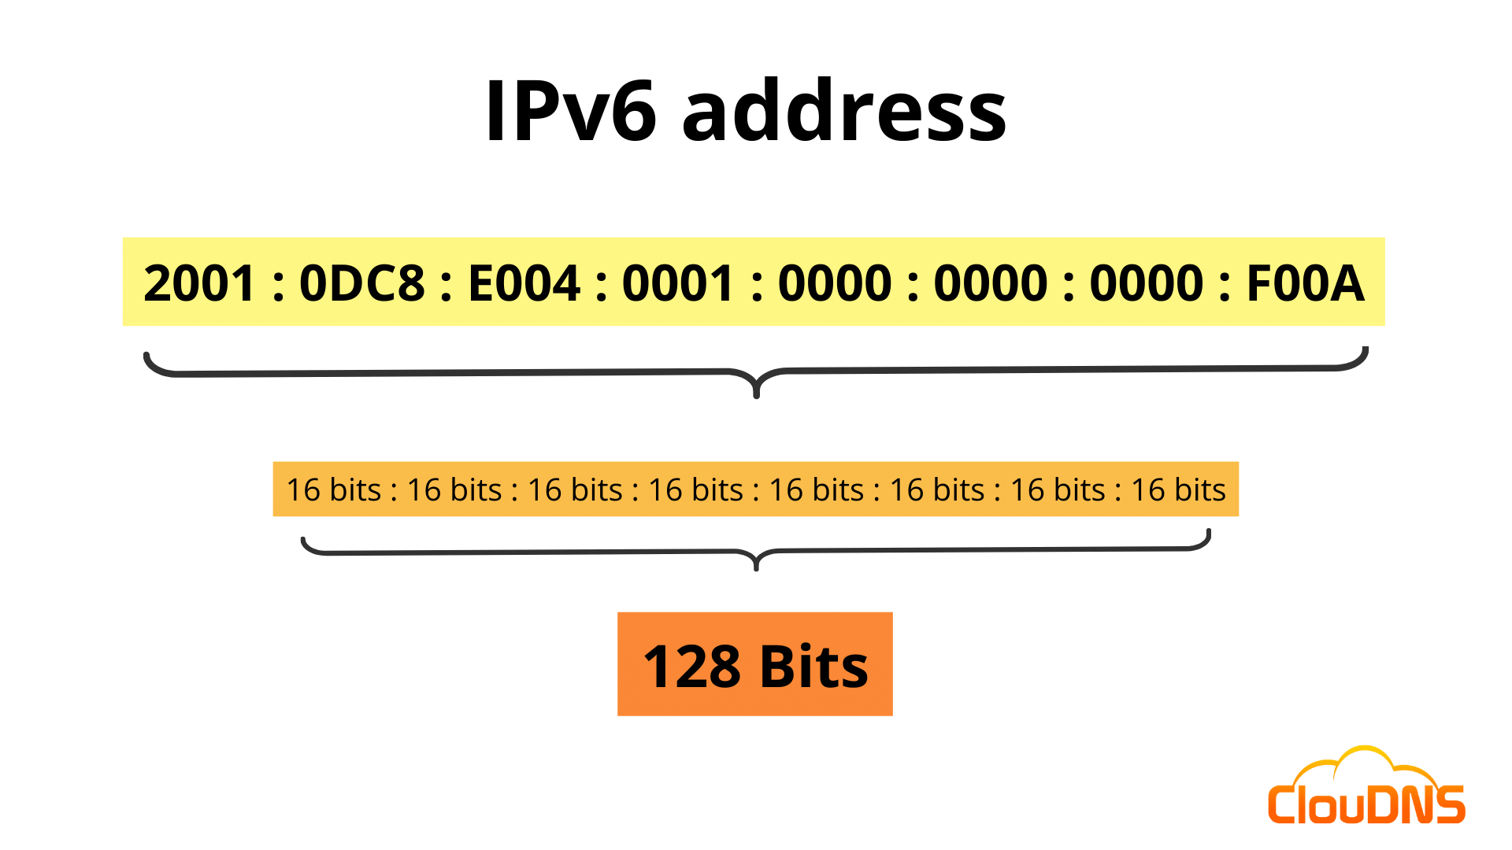
IPV6 Address Format
Characteristics of IPv6
- 128-bit Addressing: Uses a 128-bit address format, allowing for an almost unlimited number of unique IP addresses.
- Hexadecimal Notation: IP addresses are written in eight groups of four hexadecimal digits, separated by colons (e.g., 2001:0db8:85a3::8a2e:0370:7334).
- Connectionless and Connection-Oriented Support: Supports both connectionless (like UDP) and connection-oriented (like TCP) communications.
- No Broadcast: Does not use broadcasting; instead, uses multicast and anycast for efficient data delivery.
- Simplified Header Format: Has a simpler and more efficient packet header compared to IPv4, improving processing speed.
- Integrated Security (IPSec): Includes built-in support for IPSec to provide confidentiality, authentication, and data integrity.
- Auto-Configuration: Supports stateless and stateful address configuration, including automatic address assignment.
- No Need for NAT: Eliminates the need for Network Address Translation due to its vast address space.
- Improved Routing Efficiency: Reduces routing table size and simplifies network structure for faster data delivery.
- Support for New Services: Designed to work better with modern internet services like mobile IP, VoIP, and IoT devices.
Benefits of IPv6 over IPv4
The recent Version of IP IPv6 has a greater advantage over IPv4. Here are some of the mentioned benefits:
- Larger Address Space: IPv6 has a greater address space than IPv4, which is required for expanding the IP Connected Devices. IPv6 has 128 bit IP Address rather and IPv4 has a 32-bit Address.
- Improved Security: IPv6 has some improved security which is built in with it. IPv6 offers security like Data Authentication, Data Encryption, etc. Here, an Internet Connection is more Secure.
- Simplified Header Format: As compared to IPv4, IPv6 has a simpler and more effective header Structure, which is more cost-effective and also increases the speed of Internet Connection.
- Prioritize: IPv6 contains stronger and more reliable support for QoS features, which helps in increasing traffic over websites and increases audio and video quality on pages.
- Improved Support for Mobile Devices: IPv6 has increased and better support for Mobile Devices. It helps in making quick connections over other Mobile Devices and in a safer way than IPv4.
Switching From IPV4 to IPV6 : To switch from IPv4 to IPv6, there are several strategies:
- Dual Stacking : Devices can use both IPv4 and IPv6 at the same time. This way, they can talk to networks and devices using either version.
- Tunneling : This method allows IPv6 users to send data through an IPv4 network to reach other IPv6 users. Think of it as creating a "tunnel" for IPv6 traffic through the older IPv4 system.
- Network Address Translation (NAT) : NAT helps devices using different versions of IP addresses (IPv4 and IPv6) to communicate with each other by translating the addresses so they understand each other
Difference Between IPv4 and IPv6
The below table shows the difference between the IPV4 and IPV6 addressing :
Feature | IPv4 | IPv6
Address Length | 32-bit address | 128-bit address
Address Format | Decimal format (e.g., 192.168.0.1) | Hexadecimal format (e.g., 2001:0db8::1)
Configuration | Manual and DHCP configuration | Auto-configuration and renumbering supported
Connection Integrity | End-to-end integrity is unachievable | End-to-end integrity is achievable
Security | No built-in security; external tools like IPSec needed | IPSec is built-in for encryption and authentication
Fragmentation | Performed by sender and routers | Performed only by the sender
Flow Identification | Not available | Uses Flow Label field in header for packet flow identification
Checksum Field | Present | Not present
Transmission Scheme | Supports broadcast | Uses multicast and anycast; no broadcast
Header Size | Variable: 20–60 bytes | Fixed: 40 bytes
Conversion | Can be converted to IPv6 | Not all IPv6 addresses can be converted to IPv4
Field Structure | 4 fields separated by dots (.) | 8 fields separated by colons (:)
Address Classes | Has address classes (A, B, C, D, E) | No concept of address classes
VLSM Support | Supports Variable Length Subnet Mask (VLSM) | Does not support VLSM
Example | 66.94.29.13 | 2001:0000:3238:DFE1:0063:0000:0000:FEFB

